BUFFALO BUMP ’N  BOOGIE  When  September 14-16, 2018  Where  VFW Post 6251  2450 Walden Avenue, Cheektowaga, NY 14225  FEATURING  Jamie Marshall, Michael Diven,  Dancin’ Dean and Tina Foster as our DJ & instructor  A block of rooms has been reserved at  Hampton Inn Galleria Mall  1745 Walden Ave, Cheektowaga, NY 14225  (716) 894-8000; Toll Free (800) 426-7866  Special Rate $104 per night (plus tax), ask for “BBB” block.  These rates are good for September 13 – 16, 2018  Rate not guaranteed after August 13, 2018.  Reservation changes or cancellations made after 3:00 PM Eastern Time (US & Canada) on September 11 are subject to a one night room & tax penalty.  Email me for online hotel registration link.  Registration form on reverse. |  |  | Line dance  workshop  friday dance  7:30 – 11:00 pm  Friday night theme is  Down on the Farm  Saturday  Lessons 9 – 4:30pm  Includes beginner room  Lunch on your own  Open dancing between lessons  Evening dance 7:30-12  Sunday  Classic Lessons  9:30 am– 12:00 pm  Open dancing  *Complimentary snacks & beverages at evening dances  * 50/50 each evening  *Chinese Auction on Saturday  Event Director  Connie Glasier  (716) 673-1438  bbnbworkshop@gmail.com  Registration on back

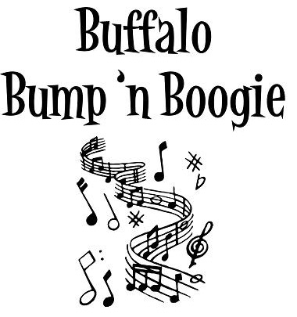 | Registration  Form  September 14-16, 2018  Register Early!  Space is Limited!

Name (please print)
Address
City State Zip
Phone (______) E-mail
Please answer: Do you plan on taking lessons in the Beginner Room for the most of the weekend? Yes No

Fee if Registration received → | On or before  June 30, 2018 | On or before  July 31, 2018 |  | After  July 31, 2018 | Total Amount
 | Circle your choice in the appropriate column.
Complete Package: Friday dance; Saturday workshop, Saturday dance; Sunday workshop | $ 75 | $ 80 |  | $ 90 | $
Saturday workshop only  and Saturday evening dance | $ 55 | $ 65 |  | $ 75 | $
Friday and Saturday evening dances only | Each $10 payable at door, no advance sale. |  |  |  | -----------
Step Sheet Booklet (prepaid ONLY) | $ 8 | $ 8 |  | $ 8 | $
Step Sheet CD  (Step Sheets only, no music, prepaid ONLY) | $ 5 | $ 5 |  | $ 5 | $
Lunch will be on your own this year. You may bring a bag lunch or go out to local restaurants. |  |  |  |  | *********
NO REFUNDS US Funds ONLY |  |  | Total Enclosed |  |  | $

Make check payable to & send to: Connie Glasier; 17B Chestnut Street; Fredonia, NY 14063

All participating parties must complete and sign an individual registration form. You will receive your registration confirmation and additional information by e-mail. If you do not have e-mail please enclose a Self-Addressed Stamped Envelope.
Submission of this form by the party listed above signifies the following: “I agree to hold the organizers of this event and their agents harmless from all suits, claims and demands of every kind and character arising out of and in conjunction with this event. I understand the physical risks of attendance and participation in this event and assume full responsibility for any injury or personal damages or loss resulting from this event named above. I certify that I am 21 years of age or older.”

Signature Date

